AI ASSISTED CODING
LAB-15.5
R. Yashritha Reddy
2303A51785
Batch-12
Task 1 – Student Attendance API
Task:
Create a RESTful API for student attendance tracking.
Instructions:
- Endpoints required: o GET /attendance → View attendance records o POST /attendance → Mark attendance o PUT /attendance/{id} → Update attendance record o DELETE /attendance/{id} → Remove attendance entry
- Ensure JSON-based request and response handling.
Expected Output:
- API for maintaining and updating attendance records.
PROMPT:
"""Generate a Python Flask REST API for student attendance with in-memory storage.
Implement GET /attendance, POST /attendance, PUT /attendance/<id>, DELETE /attendance/<id>.
Use JSON request/response and add comments."""
GIVEN CODE:
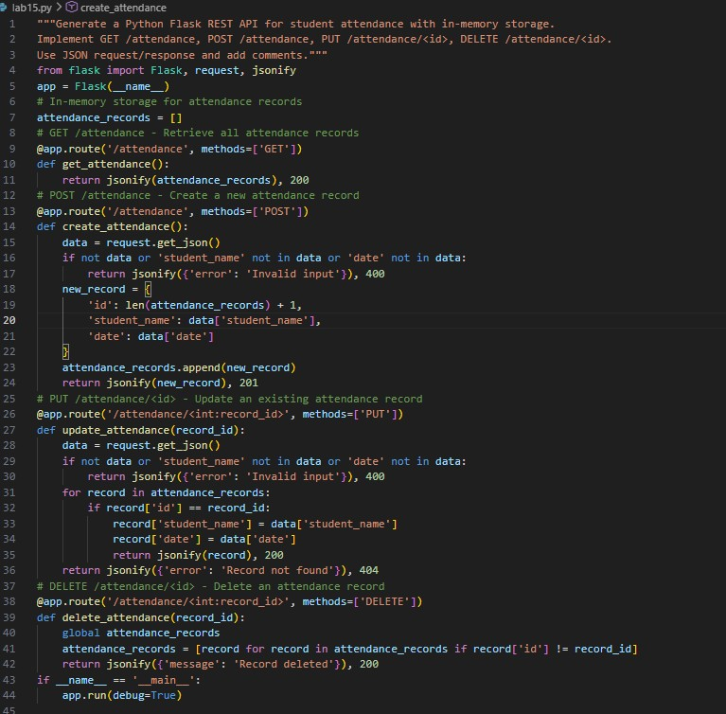

–

OBSERVATION:
The Student Attendance API was implemented using Flask to manage attendance records through RESTful endpoints. The API successfully supports operations such as viewing all attendance records, adding new attendance entries, updating existing records, and deleting records when required. JSON format was used for both request and response handling, which makes the data exchange simple and structured. The in-memory storage allowed quick testing of the API functionality. Overall, the task demonstrated how REST APIs can be used to efficiently manage student attendance data.
TASK2:
Task:
Develop a REST API for warehouse inventory management.
Instructions:
- Endpoints required:
o GET /inventory → List all items o POST /inventory → Add new item o PUT /inventory/{id} → Update stock quantity o DELETE /inventory/{id} → Remove an item
- Implement validation for stock values.
Expected Output:
- API capable of managing inventory stock levels.
PROMPT:
"""Create a Flask REST API for inventory management with item id, name, and quantity.
Implement GET, POST, PUT, DELETE endpoints for /inventory.
Add validation so stock quantity cannot be negative.""" GIVEN CODE AND OUTPUT:
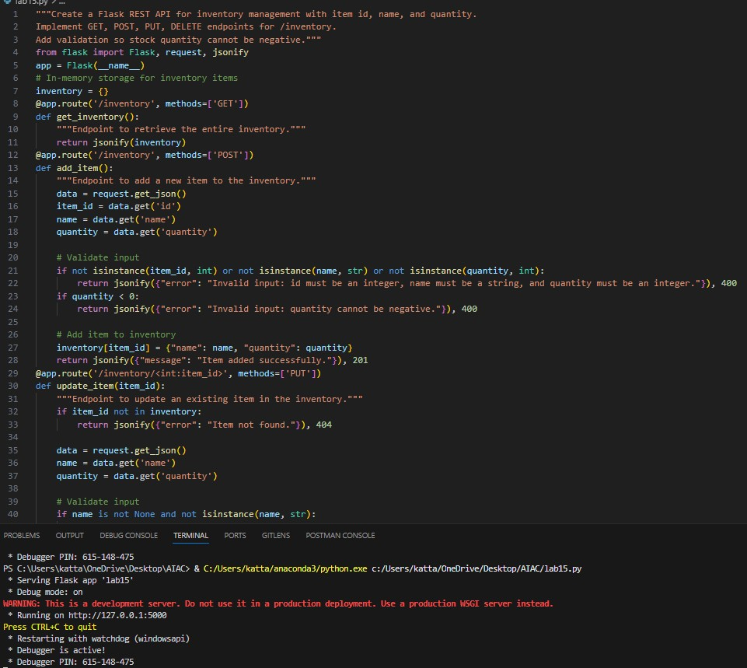
OBSERVATION:
An Inventory Management API was developed to handle warehouse stock information. The API allows users to list all items, add new items, update the stock quantity, and remove items from the inventory. Validation was implemented to ensure that the stock quantity cannot be negative, which helps maintain data accuracy. The API responses are provided in JSON format, making the system easy to interact with. This task helped in understanding how APIs can be used for managing inventory systems effectively.

Task 3 – Hotel Room Booking API
Task:
Develop a RESTful API for hotel room booking.
Instructions:
- Endpoints required:
o GET /rooms → View available rooms o POST /rooms/book → Book a room o GET /rooms/{id} → View booking details o DELETE /rooms/{id} → Cancel booking • Implement error handling for unavailable rooms.
Expected Output:
- API simulating hotel room booking operations.
PROMPT:
"""Generate a Flask REST API for hotel room booking using in-memory data.
Endpoints: GET /rooms, POST /rooms/book, GET /rooms/<id>, DELETE /rooms/<id>.
Add error handling if a room is already booked."""
GIVEN OUTPUT:
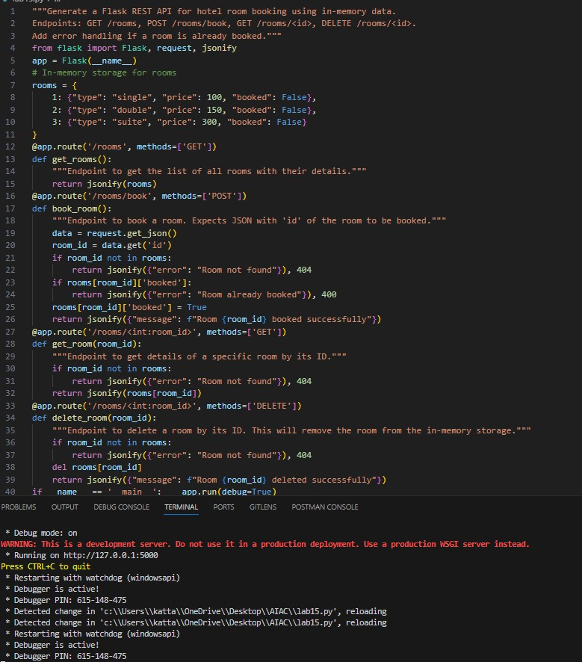
OBSERVATION:
The Hotel Room Booking API was created to simulate a basic room booking system using Flask. Through different endpoints, users can check available rooms, book a room, view booking details, and cancel a booking if necessary. Error handling was implemented to prevent booking of already reserved rooms, ensuring proper system functionality. The use of in-memory data storage made it easier to test the booking operations. This task demonstrated how REST APIs can be used to manage booking systems and handle real-time availability.

Task 4 – Online Voting API
Task:
Create a RESTful API for an online voting system.
Instructions:
- Endpoints required:
o GET /candidates → List candidates o POST /vote → Cast a vote o GET /results → View voting results
- Ensure one vote per user using in-memory validation.
Expected Output:
- API simulating a secure online voting process.
PROMPT:
"""Create a Flask REST API for an online voting system.
Endpoints: GET /candidates, POST /vote, GET /results.
Ensure each user can vote only once using in-memory validation.""" GIVEN OUTPUT:
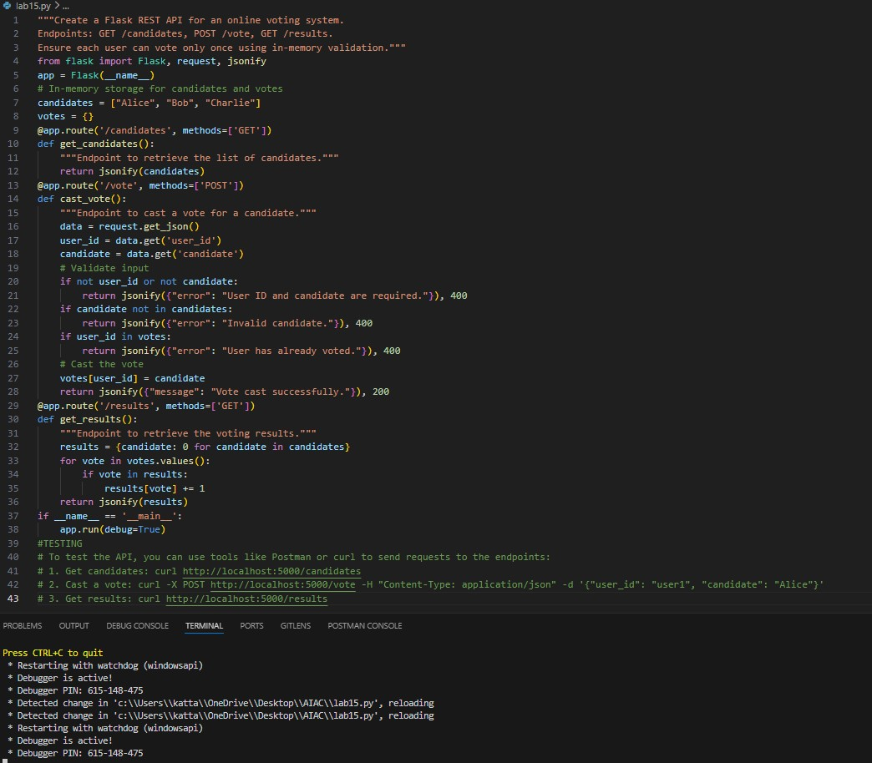
OBSERVATION:
The Online Voting API was designed to simulate a simple digital voting system. It allows users to view the list of candidates, cast their vote, and view the voting results. A validation mechanism was implemented to ensure that each user can vote only once, which maintains fairness in the voting process. The API communicates using JSON responses, making it easy to process the results. This task helped in understanding how API logic can enforce constraints and maintain secure voting operations.
Task 5 – Teacher Management API
Task:
Develop a RESTful API to manage teacher records.
Instructions:
- Endpoints required:
- GET /teachers → List all teachers
- POST /teachers → Add a new teacher o PUT /teachers/{id} → Update teacher details o DELETE /teachers/{id} → Remove a teacher • Ensure proper error handling and JSON responses.
Expected Output:
• Functional API for managing teacher information.
PROMPT:
"""Generate a Flask REST API to manage teachers with id, name, and subject.
Implement GET, POST, PUT, DELETE endpoints for /teachers.
Return JSON responses and handle errors properly."""
GIVEN OUTPUT:
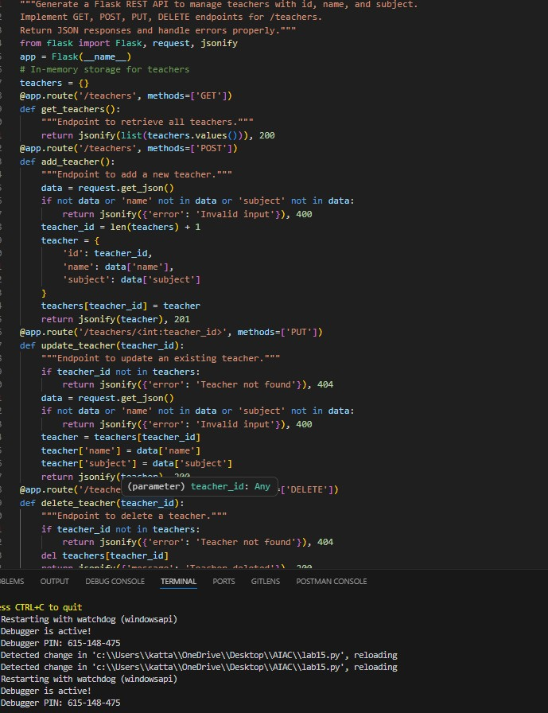

OBSERVATION:
The Teacher Management API was developed to manage teacher records through RESTful endpoints. The API allows users to add new teacher details, view the list of teachers, update teacher information, and delete records when required. Proper error handling was implemented to manage invalid requests and ensure smooth operation. All responses are returned in JSON format, making the API consistent and easy to integrate with other systems. This task demonstrated how REST APIs can be used to manage and maintain structured data efficiently.

